PUBLIC SAFFETY ANSWERING POINT (PSAP) COMPUTER ROOM IN-ROW COOLING
SCOPE OF WORK (SOW)

Shelby County 911 Emergency Communications District (Shelby ECD) is accepting bids from qualified firms to provide Computer Room air conditioning to replace the existing In-Row Cooling system for the Memphis Police Department Communications (MPD Communications) Backup Call Center. The intent is to replace the current units, with similar sized units. The Backup Call Center is in a secured facility on the twelfth floor at 201 Poplar Ave, Memphis Tennessee 38103.

The products and services of the RFB are sold to and shipped to:

City of Memphis Police Department
12th Floor (inside delivery)
201 Poplar Avenue
Memphis, Tennessee 38103
ATTN: Michael Spencer

The products and services of the RFP are billed to:

Shelby County 911 Emergency Communications District
3150 Lenox Park Blvd.
Suite 108
Memphis, Tennessee 38115
ATTN: Raymond Chiozza

Two (2) original copies of the sealed proposal and one (1) electronic copy must be clearly labeled “Custom Systems Furniture - Bid Enclosed,” and submitted to Shelby County 911 District
(the District) no later than:
2:30 p.m. on Tuesday, December 15, 2020.

The bid package including the Technical Specification Section 23 81 23, RFP with Form of Bid, and Scope of Work has been uploaded to the Shelby ECD website.

https://shelbycounty911.org/2020/10/30/mpd-backup-in-row-cooling/

A mandatory pre-bid walk through will be conducted on site 10:00am, Thursday, December 1, 2020.

Questions may be submitted in writing until 5:00 p.m. on Friday, December 11, 2020. Submit questions to: jefflupinacci@mcp911.com and lynnness@MissionCriticalPartners.com with the subject line “MPD Backup PSAP HVAC RFP Questions”. Questions submitted after this deadline will not be considered.

All questions and responses to questions will be posted on the Shelby ECD website on or before close of business Friday, December 11, 2020, and available to all interested parties. If questions are deemed to request the same information from multiple parties, the questions will be summarized into a single question and that will be responded to.

SEALED BIDS:
- What is a sealed bid?
  - A sealed bid is a bid submitted in a sealed envelope to prevent dissemination of its contents before the deadline for submission of all bids. Sealed bids are usually required by a purchasing authority on major procurements to ensure fair competition among bidders.
- What determines if a purchase is a sealed bid?
  - Sealed bids are required for any purchase or sale where the amount of expenditure or sale exceeds $25,000.00.
- What happens during the sealed bid process?
- The District will review the requisition, the department's requirements; specifications and prepare the bid package.
- The District will note the appropriate due date on the requisition in the space provided in the top right-hand side of the requisition.
- All sealed bids will be due on a Tuesday, December 15, 2020 no later than, 2:30 p.m. Bids are opened at the following location:

Shelby County 911 District
3150 Lenox Park Blvd.
Suite 108
Memphis, Tennessee 38115
ATTN: Raymond Chiozza
- Bid envelopes will not be opened before 2:30 p.m. on the due date.
- Any bid received after 2:30 p.m. shall not be opened.
- The bid opening shall be conducted by District employees or designated representatives.
- The only bids that the general public will not have access to are the bids where there is a single bidder. Single bids shall not be read aloud at the bid opening.
- After the bid opening, bids are returned to the Director who reviews each bid, prepares the tabulation and types a recommendation.
- Bids may be reviewed by the public for a specified time length and may be scheduled through the Director’s office.

The bid shall be submitted on the included ‘Form of Bid’. Any additional supporting information, including drawings, brochures, corporate information, local support organizations, etc. will be placed behind the ‘Form of Bid’.

The Bidder may include, in addition to the base-bid, optional equipment pricing itemized for materials and installation.

Required Informational Responses are also listed on the ‘Form of Bid’ for response of the Bidder.

The bid opening shall be conducted by Shelby County 911 Emergency Communications District (Shelby ECD) employees or designated representatives. After the bid opening, bids are reviewed by Shelby ECD Staff, MPD Communications, and their agents for compliance with these RFB Requirements.

Shelby ECD and MPD Communications will determine which solution and which options will best meet their needs and budget.

Shelby ECD and MPD Communications reserves the right to negotiate for a best and final offer or for revisions to the submitted bid. Shelby ECD and MPD Communications reserves the right to not award a purchase order, if they feel no solution or option met their needs.

Shelby ECD and MPD Communications reserves the right to reject any and all bids and to waive formalities.

SCOPE OF WORK (SOW)
GENERAL
- Project Objectives
  - The goal of this project is to replace the existing In-Row (air) cooling systems with liquid cooled systems.
  - The new units will provide better performance while fitting into the existing spaces of the Computer Room.
  - The successful bidder should accomplish as much pre-work as possible to minimize the amount of time that the Computer Room will be without cooling, and thus be placed ‘out of service’ or ‘unavailable’ by MPD Communications. The space where this work will be installed is an operational backup PSAP and must be completed quickly to minimize interruption of service to the public. All work will be scheduled and coordinated with MPD Communications toward this effort.
  - The successful bidder will make on-site measurements to verify the dimensions of the room and available space for cooling units prior to manufacture of their solutions.
  - The selected solution must be furnished and installed in accordance with the technical specification RFB Requirements and the Scope of Work (SOW).

- Division of labor
  - The purpose of this document is to delineate and clarify the division of labor that MPD Communications requires to successfully complete the project objectives.
  - The SOW on this project will require close coordination with MPD Communications Staff and other trades.
- Mechanical Contractor (MC)
  - The MC shall coordinate with the Electrical Contractor, the Building Owner and others to locate power connections, floor penetrations for installation of roof top mounted DX units, and grounding connections.
  - The MC shall remove the existing In-Row cooling systems. Coordinate electrical disconnection.
  - The MC shall install roof-top DX units.
    - Coordinate with the Building Owner for placement, and roof preparation for unit placement.
    - Coordinate with the EC to power roof-top units, and for the pathways needed to run the coolant lines.
    - MC shall test, start up and commission the units.
  - The MC shall install the new In-Row units.
    - Coordinate electrical power and grounding connections with the EC.
    - MC shall connect all condensate lines.
    - MC shall test, startup and commission the units.
  - MC shall provide training of operations and maintenance.
  - MC will firestop and seal all penetrations to return the surface to its original fire rating and make them water/ smoke tight.
  - MC shall replace damaged floor tiles.
- Electrical Contractor (EC)
  - The EC is responsible for all pathways, power and grounding connections for In-Row and roof-top units.
  - EC shall coordinate with MC to disconnect equipment that is being decommissioned.
  - EC will confirm that all power connections are fed from Normal Emergency (N.E.) generator backed power. HVAC units shall not be supported by the UPS system.
  - EC will tag and test all connections and document source of all connections.
  - EC shall coordinate with the MC to connect all new equipment to the single point grounding system in accordance with Motorola R-56 and ANSI/TIA-607 standards.
  - EC will be responsible to furnish and install (or coordinate, at the direction of Communications) all telecommunications requirements in this and the associated bid documents.

END OF SECTION

APPENDIX A - PROJECT DRAWINGS
The Project Drawings are diagrammatical in nature and are intended to provide details as to the design intent. They are for reference only. Do not take measurements from the drawings. Do not scale the drawings.
The Bidder must take their own measurements and is responsible for their products to fit in the actual PSAP space.
The successful bidder is responsible for a complete turnkey system as described in the specifications, shown on project drawings.

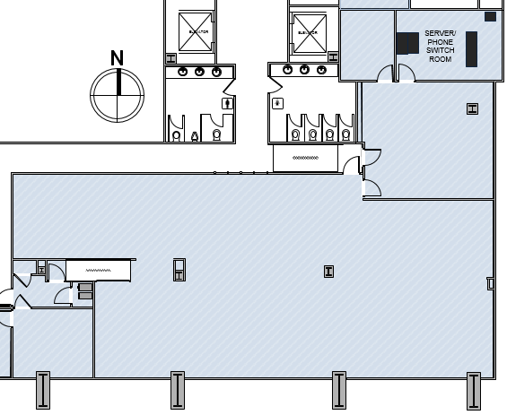
Overall Floor Plan (Not to Scale)

