PUBLIC SAFFETY ANSWERING POINT (PSAP) COMPUTER ROOM IN-ROW COOLING
Request For Bid (RFB)

Shelby County 911 Emergency Communications District (Shelby ECD) is accepting bids from qualified firms to provide Computer Room air conditioning to replace the existing In-Row Cooling system for the Memphis Police Department Communications (MPD Communications) Backup Call Center. The intent is to replace the current units, with similar sized units. The Backup Call Center is in a secured facility on the twelfth floor at 201 Poplar Ave, Memphis Tennessee 38103.

The products and services of the RFB are sold to and shipped to:

City of Memphis Police Department
12th Floor (inside delivery)
201 Poplar Avenue
Memphis, Tennessee 38103
ATTN: Michael Spencer

The products and services of the RFP are billed to:

Shelby County 911 Emergency Communications District
3150 Lenox Park Blvd.
Suite 108
Memphis, Tennessee 38115
ATTN: Raymond Chiozza

Two (2) original copies of the sealed proposal and one (1) electronic copies must be clearly labeled “MPD Backup PSAP In-Row System - Bid Enclosed” and submitted to Shelby County 911 District
(the District) no later than:
2:30 p.m. on Tuesday, December 15, 2020.

The bid package including the Technical Specification Section 23 81 23, RFP with Form of Bid, and Scope of Work has been uploaded to the Shelby ECD website.

https://shelbycounty911.org/2020/10/30/mpd-backup-in-row-cooling/

A mandatory pre-bid walk through will be conducted on site 10:00 a.m., Tuesday, December 1, 2020.

Questions may be submitted in writing until 5:00 p.m. on Friday, December 11, 2020. Submit questions to: jefflupinacci@mcp911.com and lynnness@MissionCriticalPartners.com with the subject line “MPD Backup PSAP HVAC RFP Questions”. Questions submitted after this deadline will not be considered.

All questions and responses to questions will be posted on the Shelby ECD website on or before close of business Friday, December 11, 2020, and available to all interested parties. If questions are deemed to request the same information from multiple parties, the questions will be summarized into a single question and that will be responded to.

SEALED BIDS:
- What is a sealed bid?
  - A sealed bid is a bid submitted in a sealed envelope to prevent dissemination of its contents before the deadline for submission of all bids. Sealed bids are usually required by a purchasing authority on major procurements to ensure fair competition among bidders.
- What determines if a purchase is a sealed bid?
  - Sealed bids are required for any purchase or sale where the amount of expenditure or sale exceeds $25,000.00.
- What happens during the sealed bid process?
- The District will review the requisition, the department's requirements; specifications and prepare the bid package.
- The District will note the appropriate due date on the requisition in the space provided in the top right-hand side of the requisition.
- All sealed bids will be due on a Tuesday, December 15, 2020 no later than, 2:30 p.m. Bids are opened at the following location:

Shelby County 911 District
3150 Lenox Park Blvd.
Suite 108
Memphis, Tennessee 38115
ATTN: Raymond Chiozza
- Bid envelopes will not be opened before 2:30 p.m. on the due date.
- Any bid received after 2:30 p.m. shall not be opened.
- The bid opening shall be conducted by District employees or designated representatives.
- The only bids that the general public will not have access to are the bids where there is a single bidder. Single bids shall not be read aloud at the bid opening.
- After the bid opening, bids are returned to the Director who reviews each bid, prepares the tabulation and types a recommendation.
- Bids may be reviewed by the public for a specified time length and may be scheduled through the Director’s office.

The bid shall be submitted on the included ‘Form of Bid’. Any additional supporting information, including drawings, brochures, corporate information, local support organizations, etc. will be placed behind the ‘Form of Bid’.

The Bidder may include, in addition to the base-bid, optional equipment pricing itemized for materials and installation.

Required Informational Responses are also listed on the ‘Form of Bid’ for response of the Bidder.

The bid opening shall be conducted by Shelby County 911 Emergency Communications District (Shelby ECD) employees or designated representatives. After the bid opening, bids are reviewed by Shelby ECD Staff, MPD Communications, and their agents for compliance with these RFB Requirements.

Shelby ECD and MPD Communications will determine which solution and which options will best meet their needs and budget.

Shelby ECD and MPD Communications reserves the right to negotiate for a best and final offer or for revisions to the submitted bid. Shelby ECD and MPD Communications reserves the right to not award a purchase order, if they feel no solution or option met their needs.

Shelby ECD and MPD Communications reserves the right to reject any and all bids and to waive formalities.

FORM OF BID

- BASE BID - Complete Two-Unit, In-Row, Liquid Cooled System, with Remote (Roof Top Mounted) Condenser Unit. MATERIALS (as described herein):

$ _________________________________

- BASE BID - Complete Two-Unit, In-Row, Liquid Cooled System, with Remote (Roof Top Mounted) Condenser Unit. LABOR (as described herein):

$ _________________________________

- Annual Cost for Additional Maintenance after required Warranty Period:

$ _________________________________

- Supervision and sub-contracted costs for all electrical work:

$ _________________________________

Required Informational Responses:

- Required Manufacturing Lead Time (After Notice to Proceed):

__________________________________

- Required Shipping Time to the site:

__________________________________

- Anticipated Installation Time:

__________________________________

- Required Frequency of Service:

__________________________________

- Acknowledge responsibility to provide storage and staging of materials prior to installation – Yes /No:

____________________________________

- Describe System proposed:
- In-Row Cooling Manufacturer: _____________
- In-Row Cooling Model: _____________
- In-Row Cooling Capacity - (kW / Tons): ________ / _______

END OF FORM OF BID

COMPUTER ROOM IN-ROW COOLING SYSTEMS - REQUIREMENTS
PART 1 - GENERAL
- STIPULATIONS
  - Public Safety/911 Emergency Communication Centers pose unique challenges and demands. Emergency Communications facilities are utilized 24 hours per day/ 7 days per week.
  - The successful bidder will make on-site measurements to verify the dimensions of the room and available space for cooling units prior to manufacture of their solutions during the mandatory pre-bid conference.
  - The selected solution must be furnished and installed in accordance with the Technical Specification, RFB Requirements, and the Scope of Work (SOW).
  - The SOW on this project will require close coordination with MPD Communications Staff and other trades. The space where this work will be installed is an operational backup PSAP and must be completed quickly to minimize interruption of service to the public.
  - There is limited available space in the facility to store or stage the products prior to installation. The successful bidder is responsible for any storage needed nearby the site. There is a freight elevator for transport of materials, equipment, tools and personnel to the twelfth floor.
  - Decommissioned cooling units: The old in-row cooling systems will be removed by this Mechanical Contractor (MC).
  - This MC shall supervise and sub-contract MPD Communications proprietary Electrical Contractor (EC).

Proprietary Electrical Contractor:
Wallace Electric
463 Scott Street
Memphis TN 38112
(901) 324-2149
welectri@Comcast.net

  - Coordinate with EC and others to locate power connections, floor penetrations for installation of roof top mounted DX units, and grounding connections.
- Project OBJECTIVES
  - MPD Communications is interested in receiving a bid price for two (2) new Computer Room In-Row Cooling units, with liquid cooling, and roof top mounted DX units. These units will eliminate heat from the Computer Room for the current and future loads.
  - The existing In-Row units are air-cooled and vent to the ceiling plenum. These units have not been able to keep up with the current cooling requirements.
  - The units shall be connected to the single point grounding system in accordance with Motorola R-56 and ANSI/TIA-607 standards.
  - The installation process will be as follows:
    - MPD Communications Staff will remove existing network connection from the existing In-Row Cooling.
    - The proprietary EC will de-install the existing power connections from the existing cooling units. Tag and temporarily store connections safely below the finished floor level.
    - This contractor, the MC will remove the existing In-Row Cooling Units and provide proof of their proper disposal.
    - The MC will remove any damaged raised floor tiles. Refurbish, adjust, repair, or replace (as needed) and reuse the existing pedestals. Clean under the raised floor. Work with the EC to correctly bond every other pedestal, per standards listed. Provide grommets for penetrations through the tiles.
    - The successful bidder will install the new In-Row Cooling units.
    - Pre-work may be accomplished by:
      - placing the Roof Top units and running chiller lines to the twelfth floor Computer Room. Coordinate with EC for penetration through the floor, interior and exterior walls. Return all penetrations to their original fire rating and air/smoke containment state.
      - Insulating all chiller lines for these units, and those connected to the UPS Room CRAC units.
    - The EC will install the power connections into the new In-Row Units and the roof top DX units.
    - EC will reinstall/install the two network management connections from the network switches one to each of the new In-Row Units. Install a two-port surface mounted boxes above the in-row cooling units; provide patch cords, and equipment cords.
    - The successful MC bidder will complete the installation and start-up procedures.
    - Provide the MPD Communications on the correct operation and maintenance of the new units.

- RELATED SECTIONS
  - Technical Specification Section 23-82-23 – In-Row Chilled Water-Cooling Units (Covers the specific system minimums and performance of the equipment)
  - MPD 201 Backup – HVAC Scope of Work (Covers the division of labor and coordination between HVAC (by this Mechanical Contractor) and the Electrical Contractor)
  - Appendix A - Project Photos.

- SUBMITTALS
  - Shop drawings shall be submitted based on the selected solution.
  - Shop Drawings:
    - Complete bill of materials (BOM) with part numbers and prices.
    - System layout drawings showing all components for this installation.
      - This submission shall be in .PDF and AutoCAD R13 format.
      - Detail any interface with power and telecommunications.
    - Product cut sheets indicating materials, finish, dimensions, and all accessories.

- References / Standards / Codes
  - Contractor shall comply with the most recent edition of the referenced Codes and Standards, unless otherwise noted.
    - Motorola R56® – Standards and Guidelines for Communications Sites
    - American National Standards Institute/Telecommunications Industry Association (ANSI/TIA)-607-C – Commercial Building Grounding (Earthing) and Bonding Requirements for Telecommunications
    - National Fire Protection Association (NFPA) 70 – National Electrical Code (NEC)
    - ANSI/TIA-569-E – Commercial Building Standard for Telecommunications Pathways and Spaces
    - ANSI/TIA-606-C – Administration Standard for the Telecommunications Infrastructure of Commercial Buildings
    - ANSI/TIA-942-B – Telecommunications Infrastructure Standard for Data Centers
    - Building Industries Consulting Services, International (BICSI) Telecommunications Distribution Methods Manual (TDMM), latest edition
    - ANSI/BICSI-002 – Data Center Design and Implementation Best Practices – Spaces, latest edition.
    - ANSI/HFES 100-2007 Human Factors Engineering of Computer Workstations.
    - ANSI/BIFMA X5.5-2008, Desk Products.
    - Federal Trade Commission Made in the USA Policy.
    - And those referenced in the Technical Specification.

- Experience & References
  - The manufacturer and cooling system being proposed must have a proven record of product longevity and customer service in a 24-hour operating environment of public safety dispatch centers, specifically of similar size to this request.
  - Only companies with a minimum of 25 years’ experience in designing, manufacturing, and servicing Computer Room cooling systems will be considered.
  - Provide a minimum of five (5) centers, installed in the last ten (10) years, of similar size or product with this proposal. Include agency name, location, and service representative.
  - Bidder must be the manufacturer of all major components. Any exceptions must be listed.
  - Provide similar information for any factory certified sub-contracted installers.

- Shop Drawings and Approval
  - Submit detailed shop drawings with all interfaces and equipment.
  - Detail the physical dimensions of all components to ensure adequate operating and maintenance space.

- Warranty, Service and Maintenance Agreement
  - Five (5) year coverage for all product, delivery, and installation. Absolutely no costs for materials or labor associated with replacement or repair of any portion of the product or installation will be passed on to the customer during the first 5 years of warranty.
  - Lifetime warranty on all compressor, fans, or motors components. After 5 years, labor and installation expenses associated with product replacement under the warranty will be assessed on a case by case basis.

- Lead Time & Installation
  - Provide manufacturing lead time, shipping time and anticipated installation time from date of order on ‘Form of Bid’.
  - Only the manufacturer’s factory certified installers or their trained and authorized designees experienced with the working environment of a public safety dispatch center shall assemble and install the cooling units. Documentation must be provided for installation foreman.
  - A post-installation walkthrough shall be required with the installation foreman in order to ascertain full compliance to the system design, materials specified, and intended use. Any leakage of cooling liquid or condensate will be address prior to system turnover to the MPD Communications.
  - Training is required. Provide a detailed plan for training for employees operating the units and for technicians maintaining the equipment. Provide any user performed maintenance training. Video record the training for future employees.
  - Grounding and Bonding
    - All cooling system components shall be electrically continuous and bonded to the single point grounding system.
    - Refer to Motorola R-56 for specifics.
  - User manuals must be provided.
  - Provide all necessary appurtenances for complete installation.
PART 2 - PRODUCTS

Country of Origin
  - Must comply with the “Made in the USA” Policy. Federal Trade Commission Made in the USA Policy.

Basis of Design (Base Bid)
  - Liebert CRV-DX In-Row Cooling System
  - Or approved equal

Product Dimensions
  - The available space required to replace the existing units is listed in the Technical Specification Section number 12 83 23.
  - Field verify all dimensions and building conditions during the mandatory pre-bid meeting, prior to manufacturing products. No pricing adjustments will be provided based on actual field dimensions.
  - Vendor must coordinate the installation and sub-contract with the MPD Communications proprietary EC.
PART 3 – EXECUTION

- INSTALLATION
  - Installation shall be in accordance with the manufacturer’s installation guidelines and configured per the approved shop drawings.
  - Install cooling lines and pathways to maintain system performance.
  - Grounding of the systems shall be in accordance with Motorola R56 guidelines.
  - Power connections to systems, fans, and motors shall not be connected to a UPS derived circuit. Systems shall be attached to normal emergency (N.E.) circuits which are backed up by a building generator.

END OF SECTION

APPENDIX A - PROJECT PHOTOS
The Project Photos are intended to provide basic details related to the design intent. They are for reference only. Do not take measurements or scale the photos.
The Bidder must take their own measurements and is responsible for their products to fit in the actual Computer Room and Roof-top spaces.
The successful bidder is responsible for a complete turnkey system as described in the specifications.

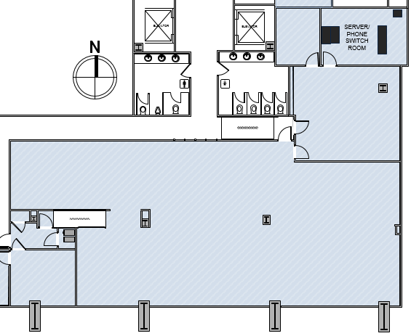
Overall Floor Plan (Not to Scale)
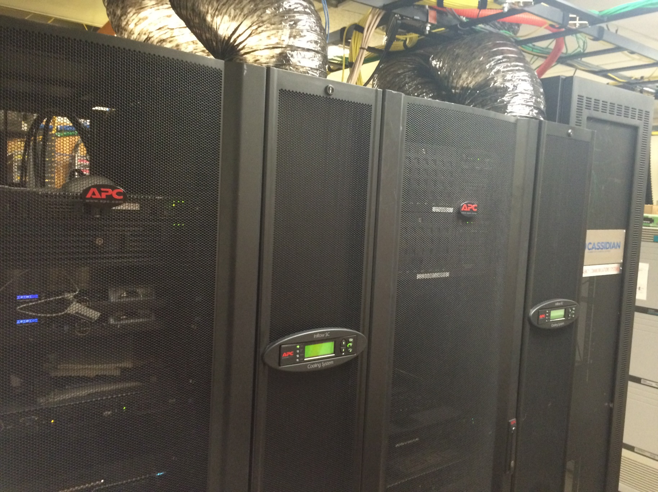
Existing Computer Room (Not to Scale)
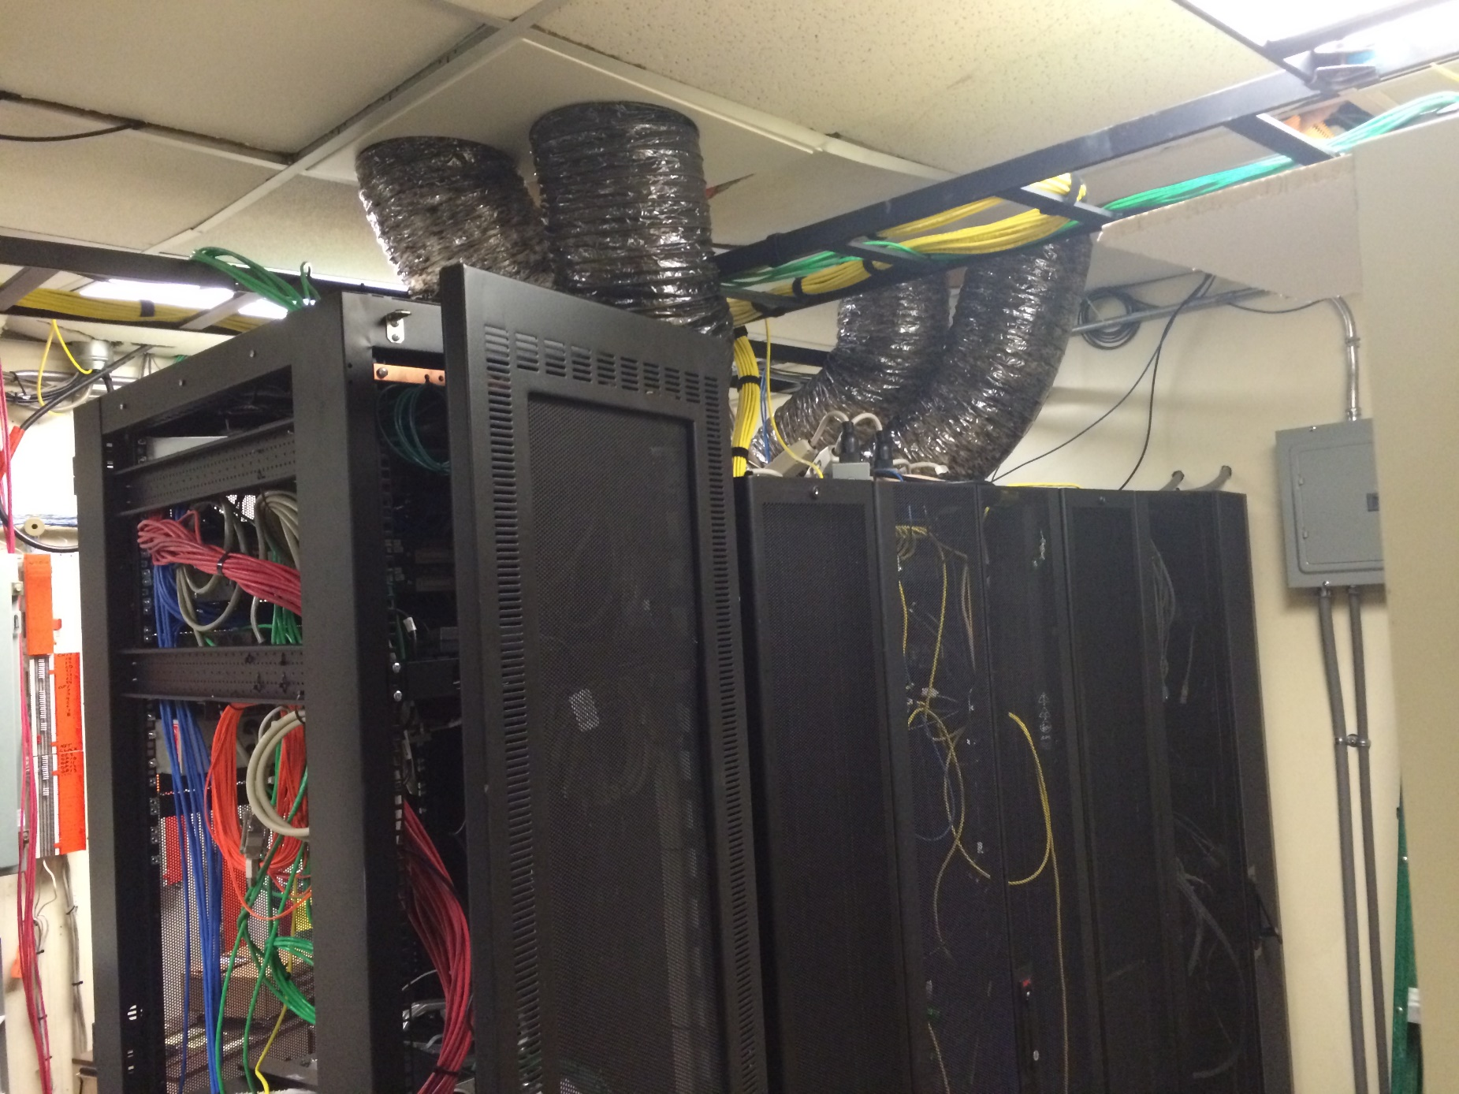
Existing Computer Room (Not to Scale)

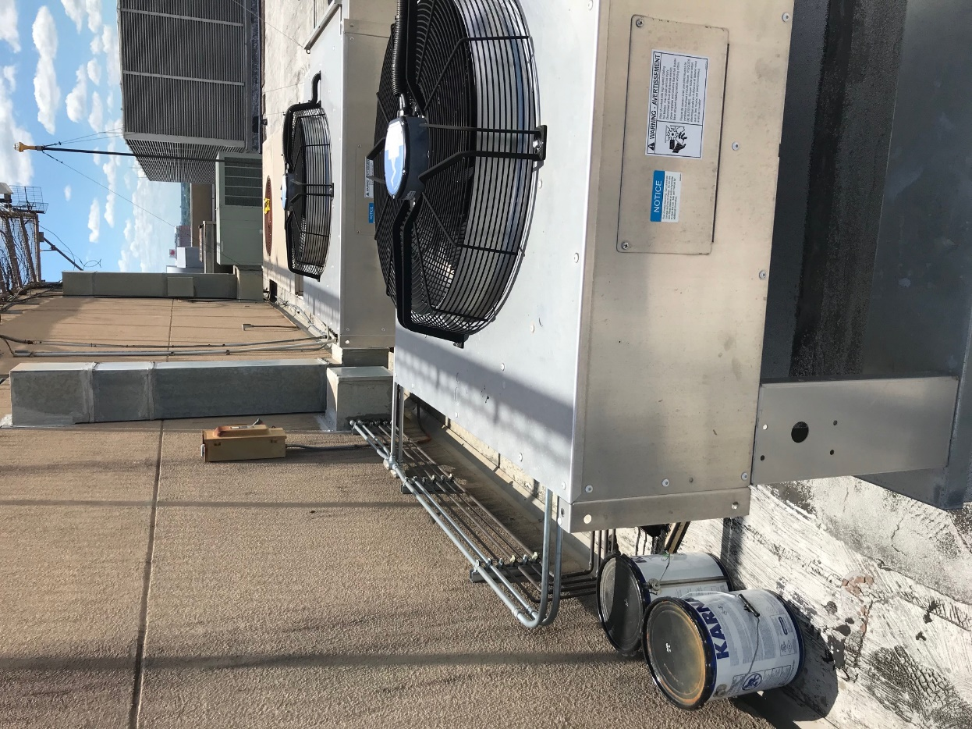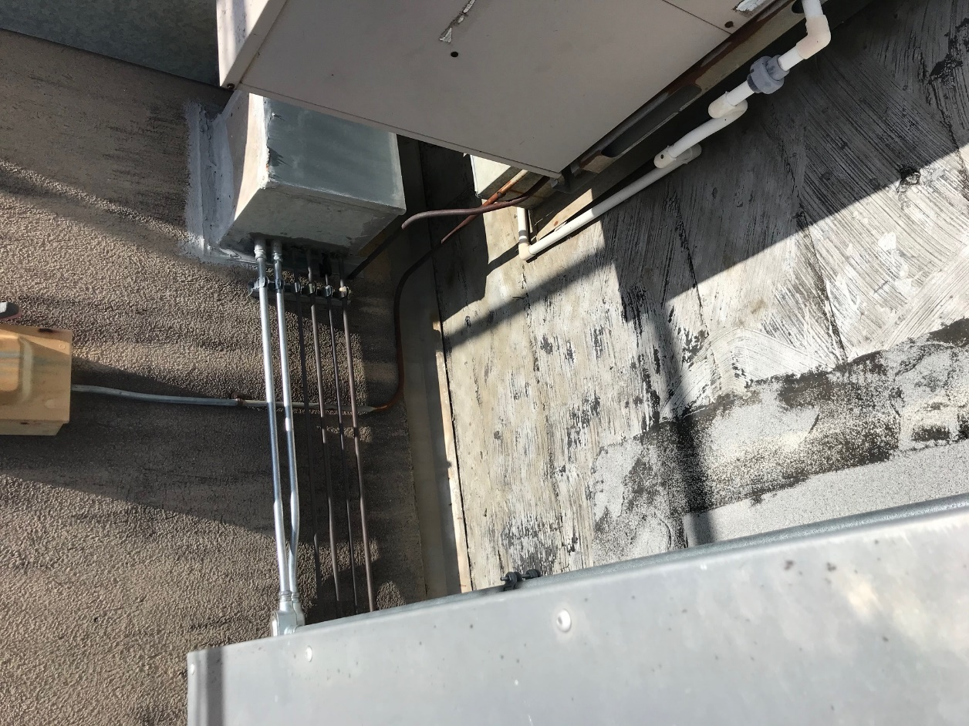

Existing Roof-Top (Not to Scale)

